**System Configuration Requirement for installation**

Operating system: Windows xp, 7 ,8 ,8.1 ,10

Ram: 2GB

Local disk space required: 1GB

Internet:1Mbps

Note: internet should be good speed no dropping during installation

**Installation guidelines**

1. MyAppinstaller-web Run as Administrator

2. Installation windows will open it will take few minutes

3. It will open window like below

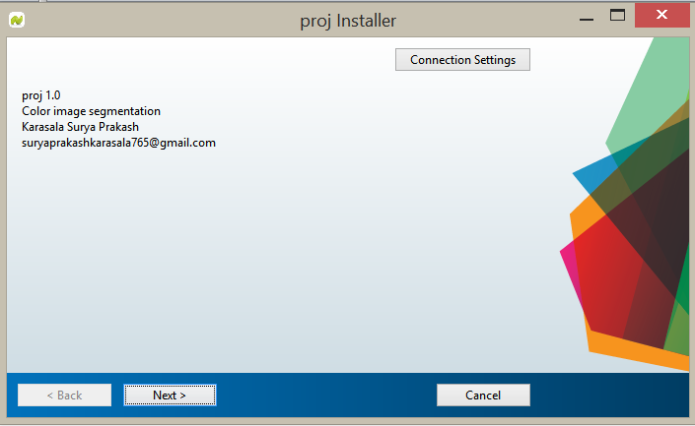

Click next

4. choose the installation folder and then click next

Select desktop shortcut it’s your choice

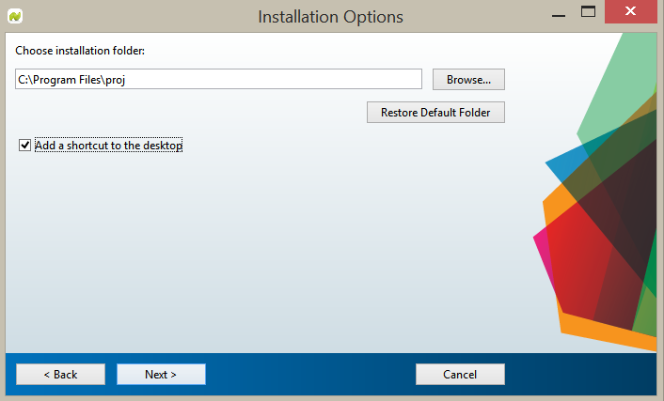

5. Chose the folder for MATLAB Runtime installation

Then click next

If already installed click next

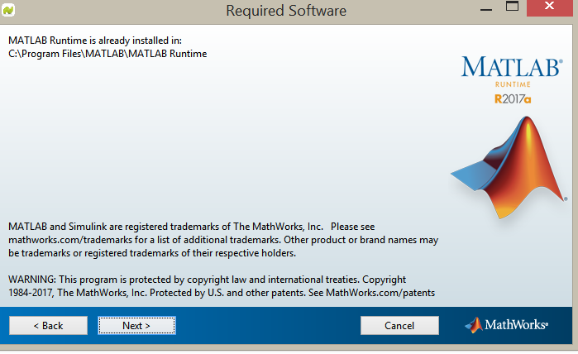

6. It will start downloading packages from internet

7. After installation completed click finish